- Lab01_1 cài đặt Git
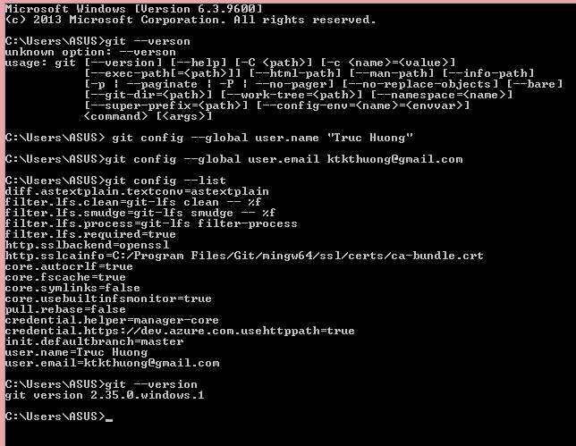
- Lab01_2 Câu lệnh Git cơ bản

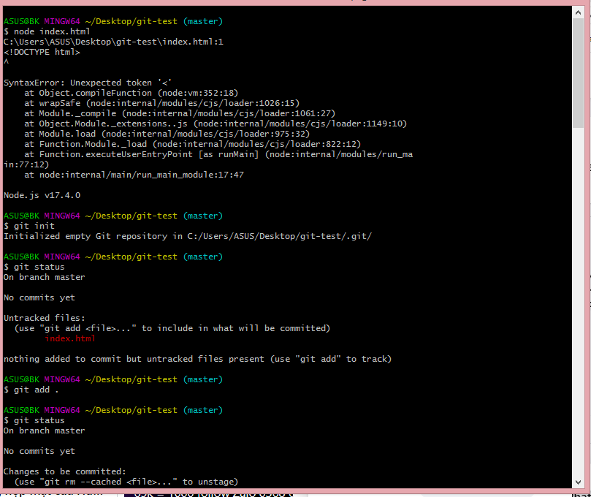
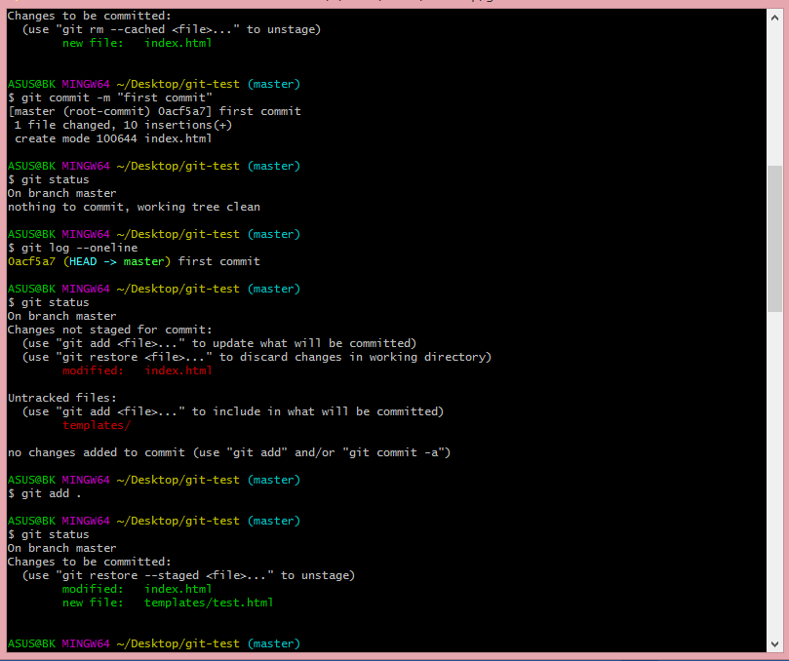
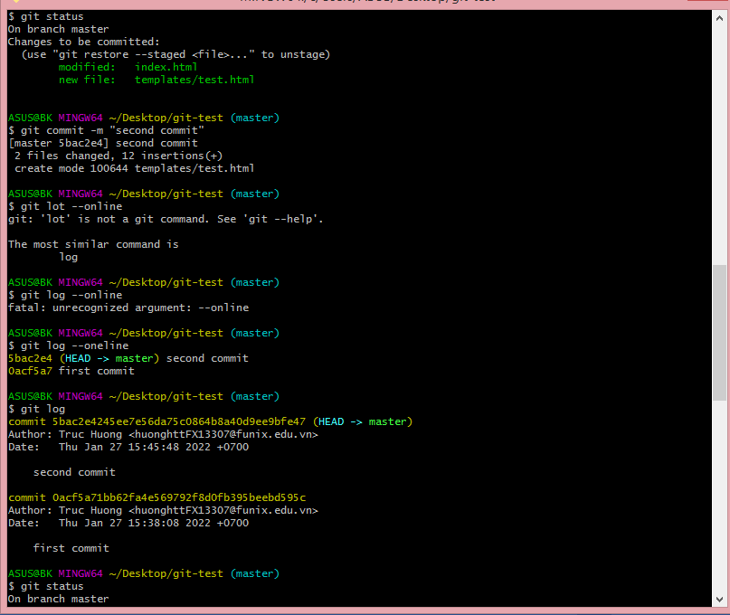
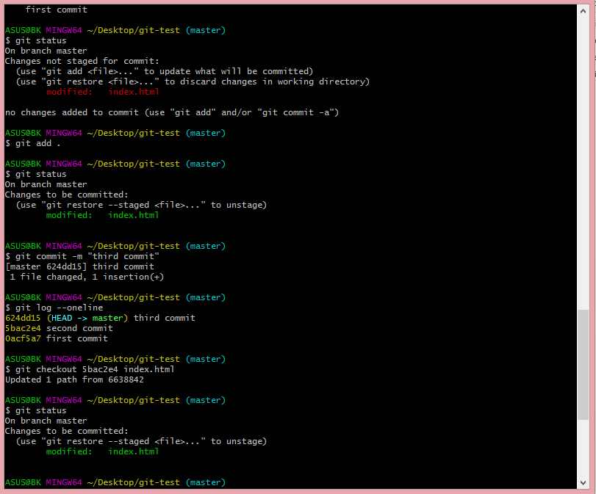
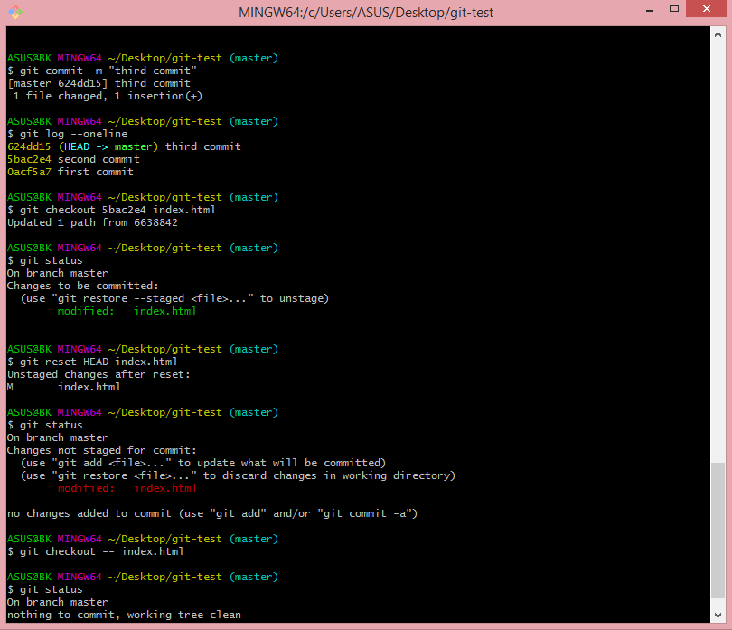

- Lab01_3 link git đã tạo: https://github.com/ktkthuong/git-test

- Lab01_4:

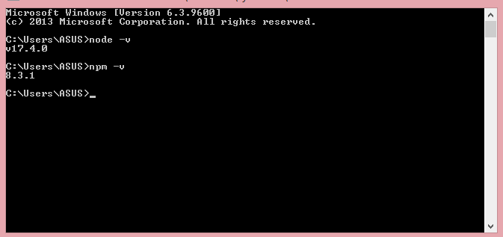
- Lab01_5 : link git đã tạo lite server: http://localhost:3000/
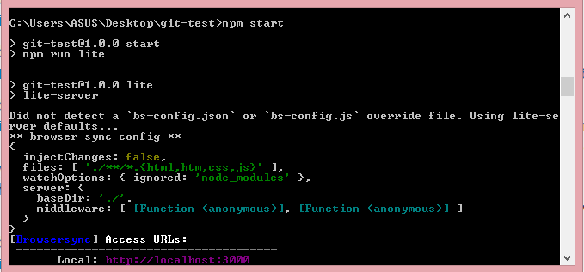

- Lab02_1: https://github.com/ktkthuong/FUNIXReactLAB02_1: http://localhost:3000/
- Lab03_1: https://github.com/ktkthuong/FUNIXReactLAB02_1/tree/LAB03_1
- Lab03_2: https://github.com/ktkthuong/FUNIXReactLAB02_1/tree/LAB03_2
- ASM1: https://github.com/ktkthuong/FUNIXReactLAB02_1/tree/RJS101x_Assignment1_huonghttFX13307%40funix.edu.vn

